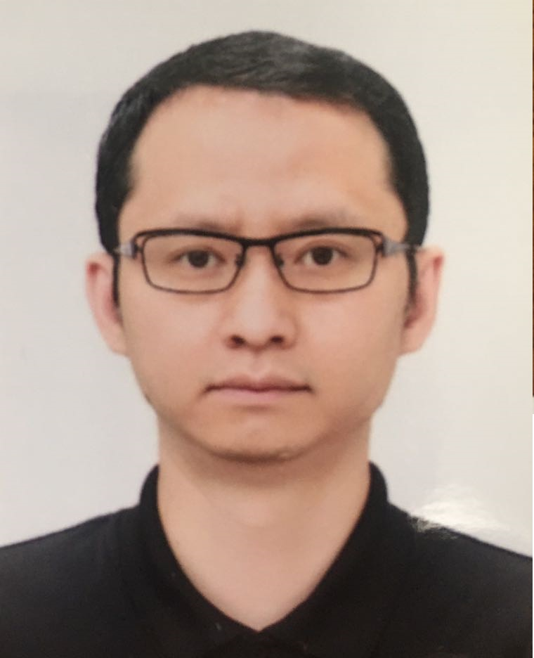 | Yang Kun
 | Mobile: +818023829456 | Nationality: China
 | Email: skyyang27@yahoo.com | Degree: Master
Address | 7-3, Shimonamiki, Kawasaki Shi Kawasaki Ku, Kanagawa Ken, 210-0025, Japan

Working Experience
HSAE Japan Co., Ltd |  |  |  | 2023.08-Present
Position: | System Engineer | Location: | Tokyo Japan
Department: | Development Center | Subordinates: | 10
Responsibilities:
The company produce in-car displays for vehicles and conducts project development based on the VDA Scope (ASPICE 3.1). Take responsibility for designing the production process and addressing any technical issues with customers. Current customer is Honda.
Main tasks are the following:

1, Take full responsibility for System Requirements Analysis (SYS.2) and System Architectural Design (SYS.3), as well as create qualification test (SYS.5) and integration test (SYS.4) documents for the test team.
2, Lead the software team in completing requirements analysis (SWE.1), architectural design (SWE.2), and detailed design (SWE.3). Review all output documents across the entire process group, from design to testing (SWE.1-SWE.6).
3, Lead the hardware team in completing similar tasks within the hardware engineering process group, including mechanical design and electrical circuit design.
4, Maintain direct communication with the customer to address all technical issues and routinely report development status.
5, Verify official deliverables at each customer milestone and present the content at official report meetings.

Neusoft Japan Co., Ltd |  |  |  | 2021.07-2023.08
Position: | Bridge System Engineer | Location: | Tokyo Japan
Department: | Software Development | Subordinates: | 5
Responsibilities:
Participate in the project to develop an in-car software application server platform for Toyota. Focus on the Software Engineering Process Group of ASPICE.
Main tasks are the following:

1, In Power Changing module and Multimedia module, take full responsibility for Software Requirements Analysis (SWE.1), as well as create qualification test (SWE.6) documents for the test team.
2, Lead the software team in completing architectural design (SWE.2), and detailed design (SWE.3). Review all output documents across the entire process group, from design to testing (SWE.1-SWE.6).
3, Make plans aligned with the customer’s development schedule to meet targets for each phase.
4, Collaborate with third-party companies to resolve cross-functional issues.
5, Participate in daily meetings to report development status and issues, and negotiate with the customer to refine the development process.

Japan Baonova Co., Ltd |  |  |  | 2019.08-2021.06
Position: | Software Engineer | Location: | Saitama Japan
Department: | Software Development | Subordinates: | 0
Responsibilities:
Work onsite in the top in-vehicle software company of Japan. The product is integrated in-vehicle software; sub-apps include navigation, intelligent voice, music, weather, news, gourmet and other apps for daily use. Based on the Scrum framework, responsible for developing and maintaining these sub-apps. End customer is Subaru.
Main tasks are the following:
1, Collaborate with the leader (Scrum Master) to develop plans at bi-weekly Sprint Planning meetings.
2, Code or test software units, report related issues at daily meetings (Daily Standup), and follow suggestions to resolve those issues.
3, Release software versions or test reports bi-weekly and present the results at Sprint Review meetings.

Biwin Stroage Technology Limited. |  |  |  | 2018.08-2019.07
Position: | Project Manager | Location: | Shenzhen China
Department: | Overseas Business | Subordinates: | 7
Responsibilities:
The company's products are mainly SSD and memory cards, and gets the exclusive agency for HP’s SSD products. So Biwin is authorized to design, produce, advertise and sell HP SSD in the worldwide scale.

Taking responsibility to the whole HP SSD project:
･Be the contact person to HP.
･Managing the internal resource to achieve the roadmap.
･Verifying the products’ package documents, avoid to violate the local laws and HP’s rule.
･Joining exhibition to advertise the HP products.

Intel China Ltd. |  |  |  | 2015.07-2017.10
Position: | Account Manager | Location: | Chengdu China
Department: | IoT Department | Subordinates: | 5
Responsibilities:
Manage IoT customers across the country and cooperate them to achieve the projects with Intel products. The main tasks including three parts:

1. Be responsible for the end-to-end process of project development, R&D, procurement, material delivery, and assisting customers in marketing.
2. Recruit new customers, hold industry market events, and report on industry market conditions and development trend of IoT field.
3. Negotiate with customers to modify and sign various business-related contracts. Write complete customer and project documentation for long-term management within the company.

Maipu Co., Ltd |  |  |  | 2014.06-2015.05
Position: | Account Manager | Location: | Chengdu China
Department: | Sales Department | Subordinates: | 1
Responsibilities:
In charge of company’s market extending of Latin America, searching for partners, and building company’s local channels.
Achievements:

1, Accomplished four transactions, Bolivia (Party B: Datatel, Cleartec), Ecuador (Party B: MEGAsupply), Chile (Party B: Lolenco);
2, Got new partners in Bolivia, Ecuador, Chile, Colombia, Peru, Uruguay and so on;
3, Opened market in Argentina and Central America, let local customers to know Maipu brand at first time and discuss the cooperation.

Sobey Digital Technology Co., Ltd |  |  |  | 2009.07-2014.04
Position: | Software Engineer | Location: | Chengdu China
Department: | Software Development | Subordinates: | 0
Responsibilities:
In the first two years, coding for well-known non-linear editing software systems in the development department, focus on three-dimensional effects development, main tools include C++, C, OpenGL, SQL, etc.
Position: | System Engineer | Location: | Chengdu China
Department: | Overseas Business | Subordinates: | 0-7(Depend on project size)
Responsibilities:
In the next three years, transferred to the system support department, taking responsibility for sales support, on-site integration and follow-up maintenance; customer problem collection and processing, relationship maintenance and system usage training. The main partner is Sony, Japan.
Main project introduction:
1. During half year period, project managers and engineers from China, Japan and Korea jointly established the Seoul Yonhap TV system. Outcome: Complete the software editing system for hundreds of people.
2. During one year period, fully manage the project in Osaka, Japan, and cooperate with local engineers to build the daily TV station system in Osaka. Outcome: complete the software editing system meeting the stringent requirements of Japanese customers.
3. San Jose, USA, MWU University teaching system; Hong Kong, TVB System maintenance.

Education
School | Major and Degree | Duration
Enforex - International Language Center of Madrid | Spanish | 2017.12-2018.07
University of Electronic Science and Technology of China | Pattern Recognition and Artificial Intelligence  / Master | 2006.09-2009.06
Southwest University for Nationalities | Electronic Engineering  / Bachelor | 2001.09-2005.06

